1 Analyzing data with large language models

This chapter covers
- Introduction to language models
- Target audience and prerequisites
- Data analysis with language models
Please ignore grammar errors and typos. What you see is a raw manuscript; it has not been copyedited.
Language models are powerful neural networks that can be used for various language processing tasks. This chapter introduces language models and shows how and why we want to use them for data analysis. You will learn about use cases, recommended background before reading this book, and challenges that arise when using language models in practice.

1.1 What can language models do?
We will start this section with a little poem and associated picture (Figure 1.1), connecting the two main topics of this book: data science and AI.

Figure 1.1 Illustration by GPT-4o for the topic “AI-Assisted Data Science”.
Up - interesting

In the realm where data’s vast oceans flow,
And mysteries in numbers softly glow,
There lies a dance, both precise and free,
A blend of man and AI’s harmony.
Algorithms hum in rhythmic tune,
Deciphering secrets under the moon.
Charts and graphs, a language so pure,
Speak tales of trends, both obscure and sure.
Human hands guide with intuition’s grace,
While machines compute at a rapid pace.
Together they unravel the intricate threads,
Of knowledge hidden in data’s beds.
AI, a partner in this grand quest,
Helps uncover insights, the very best.
With circuits and codes, it sees the unseen,
Turning raw numbers into a vision serene.
Yet within this partnership so bright,
Human wisdom remains the guiding light.
For in each byte and binary trace,
There’s a touch of humanity’s embrace.
In this world of pixels and lines,
Where digital and analog entwine,
AI-assisted data science thrives,
A testament to how our knowledge strives.
The poem above has been generated by GPT-4o (“o” for “omni”), a language model by OpenAI that processes multi-modal data, solely based on the instructions “Write a poem about ’AI-Assisted Data Science’ and draw a corresponding picture!”. Both, the picture and the poem, relate indeed to the input topic (AI-Assisted Data Science). While the poem may not win any literature awards, the poem text is coherent, structured as we would expect from a poem, and it rhymes! Perhaps most importantly, all it took to generate poem and picture is a simple command, expressed in natural language. Whereas prior text generation methods rely on large amounts of task-specific training data, this requirement is now obsolete. And, of course, the task is specific enough to convince us that the language model is not copying existing solutions from the Web and generates original content instead.
Writing poems and generating pictures are only two out of many possible use cases (albeit, possibly, the most entertaining ones). Models like GPT-4o are able to solve a variety of tasks such as summarizing text documents, writing program code, or answering questions about pictures. In this book, you will learn how to leverage language models to accomplish a plethora of data analysis tasks, ranging from calculating aggregates over data tables up to extracting information from large collections of text documents. We will exploit language models to analyze data directly as well as use them as an interface to external data analysis tools. After reading this book, you will be able to quickly build data analysis pipelines that are based on language models and extract useful insights from a variety of data formats.

What does GPT stand for?
GPT stands for Generative Pre-Trained Transformer. Let us look at each individual term to understand the semantics:
Any comments on section 1.1 What can language models do??

Up – well explained.

1.2 Who should read this book
This book is for you if you are working with data or if you plan to work with data. You might work in a profession that requires data analysis, e.g., a data scientist, data engineer, database administrator, or perhaps a data journalist, business analyst, or scientist. On the other hand, you might simply be curious about all the amazing insights that can be gained by analyzing publicly available data sets. In any case, this book will help you expand your efficiency and your reach when it comes to data analysis.
In this book, we’ll be using the latest generation of language models. Typically, you can instruct those models in natural language, i.e., in plain English, on what they need to do. That means using them does not necessarily require a deep background in computer science. At the beginning of this book, we will see interfaces that allow you to use language models for data analysis via natural language instructions alone. However, to support more complex data analysis scenarios, we will need to write custom code that exploits language models. In this book, we will use the Python programming language to do that. You should be familiar with Python at least at a beginner’s level in order to follow later chapters of this book.
Any comments on section 1.2 Who should read this book?

Up – Well explained.

1.3 Why you should read this book
Whether you are a novice analyst or an experienced data professional, language models can help you to expand your reach in data analysis. If you are an experienced developer, large language models can boost your productivity and generate analysis results at a level of quality that was not possible with prior methods. If you are a novice analyst, large language models enable you to accomplish novel analysis tasks easily due to their simple, natural language interfaces.
Any comments on section 1.3 Why you should read this book?

Up – Well explained.

1.4 What you will learn
This book is about using language models for data analysis. We can categorize data analysis tasks by the type of data we’re analyzing and by the type of analysis. This book covers a wide range of data types and analysis tasks. Data is typically categorized as either structured or unstructured, defined next.
Unstructured data includes various data types that do not follow a pre-defined structure. That includes, for instance, free text, images, videos, and audio files.
Structured data follows a pre-defined schema. That includes, for instance, data tables (their structure is defined by the columns and their types and each row contains values for the same columns) as well as data describing graphs such as social networks.
We’ll discuss how to apply language models to analyze all of the aforementioned types of data in this book, covering many common analysis tasks such as automatically classifying data, extracting structured information from unstructured data, clustering data into groups of similar elements, as well as answering complex questions about data, possibly integrating multiple types of data to find an answer. While you will learn “recipes” to solve common tasks using language models, by the end of this book, you should be able to adapt what you learned to create customized solutions as well.
While most of this book focuses on data analysis using OpenAI’s GPT model series (a collection of powerful models that enable you to cover a wide range of scenarios), we will also discuss about alternative providers and models that may lead to better results or reduced costs. As the Application Programming Interfaces (APIs) of different providers tend to be similar, familiarizing yourself with a new provider interface will be quick.
Any comments on section 1.4 What you will learn?

Up – Well explained.

1.5 How to use language models
A language model is a large neural network for language processing (some of them process other data types in addition to text, e.g., images). Up until a few years ago, language models had to be specialized to specific tasks (e.g., classifying product reviews as either expressing satisfaction or dissatisfaction) using task-specific training data (e.g., a set of sample reviews with associated classification results). However, that’s not the case anymore for the newest generation of language models (which we focus on in this book)!
So how do we use such language models instead? Before we discuss that, let’s first introduce an important term.
A prompt is a short text, possibly complemented by additional items such as images, that forms the input to the language model. This prompt describes a task to solve by the language model, e.g., in plain English. It may also provide context information, needed to solve the task. And, if we want to make things a bit “easier” for the language model, we can help by providing a few (typically less than ten) examples of successfully solved tasks as part of the prompt.
Let’s make all of that more concrete by an example prompt. For instance, a classical use case for language processing is determining the sentiment behind product reviews, i.e., whether customers are happy or unhappy with a product. If using a state-of-the-art language model for that task via prompt, we definitely should integrate a few pieces of key information into that prompt:
This is how the prompt could look like:

Listing 1.1 Example prompt for classifying product reviews
We are considering product reviews for laptops.
For each review, output ``satisfied" or ``dissatisfied",
depending on whether the customer is satisfied
with the product or not.
Examples:
This is a great laptop! I recommend everyone to buy it!
satisfied
This laptop did not work. I had to return it.
dissatisfied
The screen is too small and it takes too long to start.
copy
Up – understood.
The example prompt contains a description of relevant context , a task description , and two examples ( and ), followed by the review we actually want the model to classify . We can then submit this prompt to the language model which will hopefully return “dissatisfied” as that is the expected answer for the last review. In the next chapter, we will actually submit prompts similar to the one in Listing 1.1.
Any comments on section 1.5 How to use language models?

Up – understood.

1.6 Using language models for data analysis
So how can we use language models for all those data analysis tasks described in Section 1.4 (and others)? The answer depends on the data properties.

1.6.1 Using language model directly on data
First of all, we can use a language model directly on the data. That’s the situation depicted in the previous section. We process text data (a product review) by classifying it into one of two categories (satisfied or dissatisfied). If we use the language model directly to process data, we need to integrate the data into our prompt.
Typically, we do not want to process a single review (doing that by hand is faster) but, rather, an entire collection of reviews. More generally, we often want to solve the same task for different data items. In those cases, we can use one prompt for each data item. Specifically, we can submit one prompt for each review and collect the review-specific reply from the language model. In those cases, the different prompts are quite similar. The only thing that changes between prompts is the review text but not the task or context.
To describe similar prompts that differ only in few places, we typically define so-called prompt templates.
A prompt template is a prompt where certain parts have been substituted by placeholders.
For instance, to classify a large number of reviews, we can specify a prompt template that is derived from the prompt in Listing 1.1:

Listing 1.2 Prompt template for classifying laptop reviews
We are considering product reviews for laptops.
For each review, output ``satisfied" or ``dissatisfied",
depending on whether the customer is satisfied
with the product or not.
Examples:
This is a great laptop! I recommend everyone to buy it!
satisfied
This laptop did not work. I had to return it.
dissatisfied
[ReviewText]
copy
Up – understood.
The task description , the problem context , as well as the examples can remain constant across different reviews. On the other hand, the review text will be substituted for each new review. Hence, the prompt template contains a placeholder for the review text .
The prompt template is used in the following way. Given a collection of data items (e.g., reviews), we replace the placeholders in the prompt template by concrete data for each item (e.g., we insert text of a specific review). The resulting prompts don’t contain any placeholders anymore and are submitted to the language model. Then, we collect the output from the language model for each prompt. Figure 1.2 illustrates this process.

Figure 1.2 Using language models directly for data analysis: a prompt template describes the analysis task. It contains placeholders that are substituted by data to analyze. After substituting placeholders, the resulting prompt is submitted to the language model to produce output.
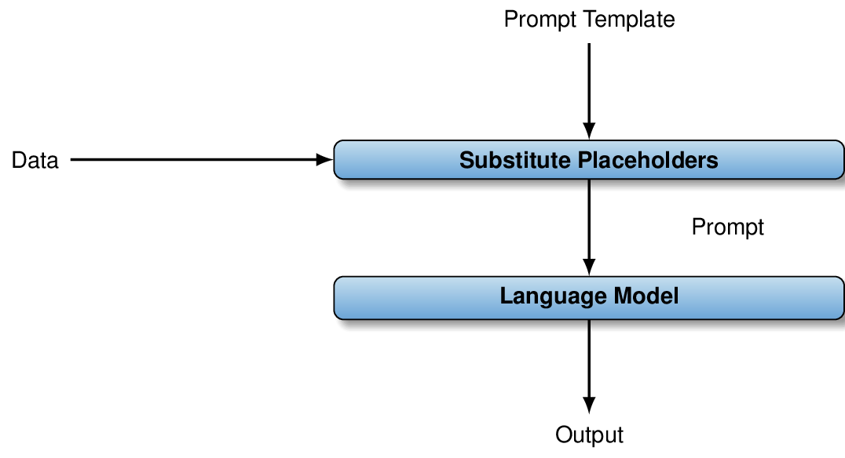

Up – understood.

1.6.2 Data analysis via external tools
The aforementioned approach works well for tasks that language models excel at. For instance, this includes tasks such as text summarization, answering questions about images, or classifying videos. On the other hand, language models tend to be bad, e.g., at tasks that require mathematical calculations (e.g., counting elements with specific properties). For such tasks, it is much better to use external tools for data processing.
Now you might be wondering: if we use external tools for data processing, how do language models fit into the pictures? Language models can be helpful as an interface that translates commands given, for instance, in English into commands that are understood by the external tool. For instance, let’s say we’re interested in processing tabular data. In that case, we can use the following tool for data processing.
A relational database management system (RDBMS) manages relational data, i.e., a collection of data tables. Many RDBMS support the structured query language (SQL) that enables users to formulate queries to, e.g., filter, aggregate, or combine data from different tables.
Formulating SQL queries to process data can be daunting, especially for lay users with limited IT background. However, using language models, we can build a much more natural interface on top of the RDBMS.
A natural language query interface (NLQI) enables users to formulate questions about data in natural language (e.g., plain English). NLQIs typically translate such questions into queries in formal languages (like SQL), process them, and return the result to the user.
In this scenario, we prompt the language model to write SQL queries, given a question in natural language. This means the prompt tasks the language model to translate English questions into SQL queries. Relevant context includes, for instance, the names of data tables in the RDBMS, as well as the names of their columns and, possibly, data samples. The result of translation (an SQL query) is not directly returned to the user. Instead, it is forwarded to the RDBMS and processed there. The query result is then forwarded to the user. Figure 1.3 illustrates this situation.

Figure 1.3 Using language models indirectly to build a natural language interface for tabular data: the prompt template contains placeholders for questions about data. After substituting placeholders, the resulting prompt is used as input for the language model. The model translates the question into an SQL query that is executed via an RDBMS.
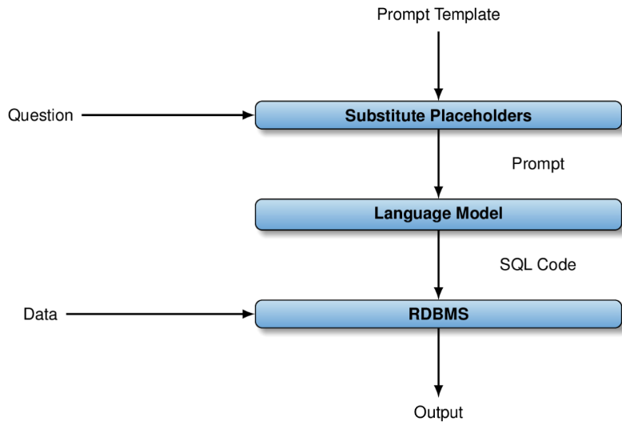

Up – understood.
This book will teach you to build NLQIs via language models for yourself and for other users. While RDBMS are used as an example here, the approach itself generalizes to various types of tools, data, and analysis tasks.
Any comments on section 1.6 Using language models for data analysis?

Up – understood.

1.7 Model providers

Figure 1.4 Holistic Evaluation of Language Models (HELM): comparing language models offered by different providers according to various metrics.
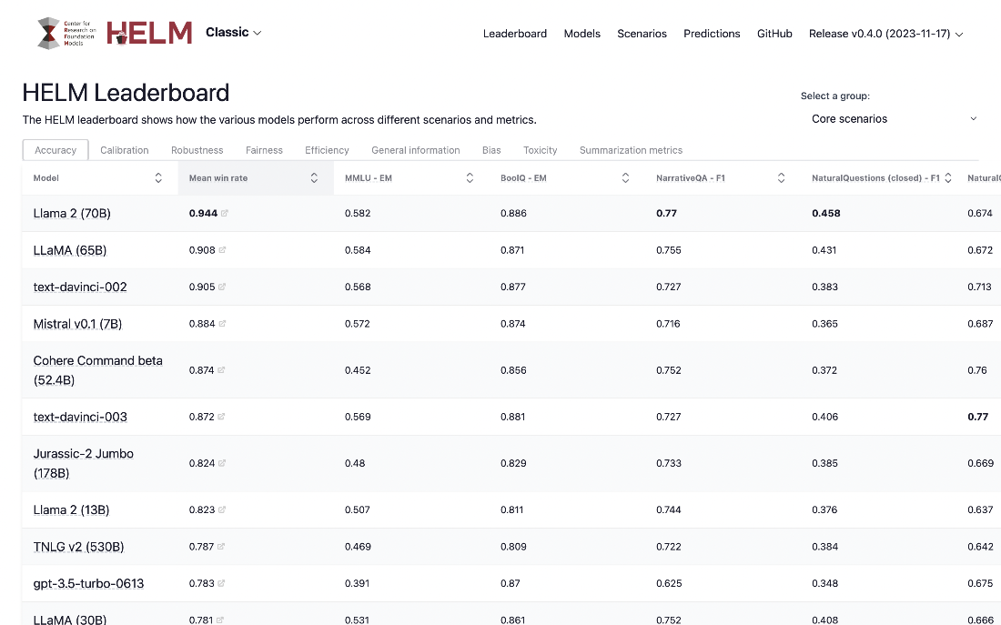

Up – understood.
Nowadays, language models are offered by various providers, including, for instance, OpenAI, AI21, Anthropic, Cohere, Huggingface, and many others! The type of models, as well as the way in which they are offered, differ across providers. For instance, some providers, like OpenAI, offer their models as a service in the Cloud. This means we do not have to install specialized software or hardware. Other providers, such as Huggingface, also enable users to download models and to execute them on their own platforms, an approach that allows for more customization.
The best choice of a provider depends on the level of experience of the user as well as on the properties of the data analysis task. At the beginning, it is probably best to focus on a single provider (to avoid having to learn about too many interfaces and model types all at once). Later, we can expand the set of providers we consider to choose the optimal one for each task. In this book, we will initially focus on OpenAI and its GPT model series. As OpenAI offers models as a service, this will enable us to get started quickly without getting into the details of how to set up language models on our local machines. Later, we will expand the scope to other providers and discuss the pros and cons of different offerings (e.g., in terms of accuracy, generality, and pricing).
Tip As the number of model providers increases, it becomes harder to find the best option for a given task. Benchmarks such as HELM (Holistic Evaluation of Language Models)¹, shown in Figure 1.4, help users choose between different providers.
Any comments on section 1.7 Model providers?

Up - Would help to give an example of using the table to select a model.

1.8 Optimally using language models
To get the best results, you have to use the selected language model optimally. Language models come with various configuration parameters and their settings can have significant impact on output quality and processing costs. The same applies to the prompt template: by expressing the same task differently, we can often see a wide range of output behaviors. The next two subsections discuss those tuning choices in more detail.

1.8.1 Selecting a model configuration
Language models can be tuned by various parameters. This includes, for instance, parameters describing termination conditions when generating output. OpenAI enables users to specify termination conditions based on the length of generated output as well on text patterns (i.e., output stops once these patterns are generated). Setting weak termination conditions may unnecessarily increase generation costs (as it allows the model to generate irrelevant content) while setting overly strict conditions may lead to incomplete results.
Beyond termination conditions, providers such as OpenAI typically offer various parameters that enable users to customize how output is generated. At a minimum, users can control the degree of randomization used when generating output. Increasing the degree of randomization can be necessary if initial output is incorrect. Typically, providers offer more fine-grained parameters, influencing, for instance, whether the model is rewarded or penalized for producing specific words in its output. In later chapters, we will discuss some of the most important tuning parameters and experiment with different settings to demonstrate their impact.

1.8.2 Choosing a prompt template

Figure 1.5 PromptBase: a Web site for selling and buying templates for prompts, short text documents used to describe tasks to a language model.


Up – Understood.
The prompt template determines how we instruct the model to solve a certain data analysis task (see Section 1.6.2 for an example). Which context should we provide for the model? How should we formulate the task description? Do we provide examples to help the model solve the task? If so, how many examples should we provide? And which ones?
It turns out that the prompt template has significant impact on the output quality. Finding good prompt templates for specific tasks requires some experience and, perhaps, experimentation to compare different versions. In later chapters, we will experiment with different prompt versions and compare their impact on cost and output quality.

Where to get prompt templates?
Finding a good prompt template for a new task may take some time. If you do not want to spend that time yourself, have somebody else do it for you! More precisely, you nowadays find platforms on the Web that enable users to buy and sell prompt templates. One of them is PromptBase, accessible at https://promptbase.com/. Figure 1.5 shows the corresponding start page. Say you want to translate English questions into SQL queries. By entering corresponding keywords, you will find not one but multiple alternative prompt templates on that platform. If, based on the associated description, the prompt template seems like a good match, you can then buy it and use it for your data analysis needs. Besides PromptBase, there are a few other platforms with similar functionality.
Any comments on section 1.8 Optimally using language models?

Up – Understood.

1.9 Advanced software frameworks
Sometimes, extracting interesting insights from data may require combining multiple different types of data. For instance, perhaps we want to combine text from product reviews with tabular data describing the associated products. And maybe we even want to integrate information that we gain from the pictures of these products as well! In such cases, we often need to combine multiple analysis methods and analysis tools. For instance, in the latter scenario, we may want to use a language model to analyze text directly, as well as a relational database management system to process tabular data. In those cases, we may have to build more complex data analysis pipelines that integrate multiple analysis steps.
Over the past few years, several advanced software frameworks have appeared that facilitate building complex applications with language models. In this book, we will explore two of these frameworks, namely LangChain² and LlamaIndex³. Both frameworks make it easier to create multi-step data analysis pipelines that may integrate different types of analysis and models, as well as different types of data.
Furthermore, frameworks like LangChain make it fairly easy to leverage advanced approaches that are based on language models. For instance, towards the end of this book, we will see how to build agents for data analysis, based on language models. Such agents put the language model intro the driver seat and use it to decide which data analysis steps to take next (rather than relying on a hard-coded data analysis pipeline). This approach yields maximal flexibility and is applicable to a variety of data analysis tasks.
Any comments on section 1.9 Advanced software frameworks?

Up – Understood.

1.10 Summary
- Language models can solve novel tasks without specialized training.
- A prompt is a short text, instructing a language model on a task.
- A prompt contains a task description, context, and optionally examples.
- Language models can analyze certain types of data directly.
- When analyzing data directly, the data must appear in the prompt.
- Language models can also help to analyze data via external tools.
- E.g., language models can instruct other tools on how to process data.
- Language models are offered by various providers.
- Models can be configured using various configuration parameters.
- Prompt templates contain placeholders, e.g., to represent data items.
- By substituting placeholders in a prompt template, we obtain a prompt.
- The structure of the prompt template has significant impact on performance.
- You can design your own templates or use platforms like PromptBase.
- Analyzing data may involve multiple analysis steps.
- Frameworks like LangChain make it easier to create multi-step analysis pipelines.
¹ https://crfm.stanford.edu/helm/v0.2.0/?models=1↩︎
² https://langchain.com/↩︎
³ https://www.llamaindex.ai/↩︎
What did you think of this chapter?
hide feedback

1
How many stars would you give this chapter?
5

2
What is your overall impression of this chapter?

- good section lengths
- good diagrams
- good tone
- avoids technical jargon that could be intimidating to beginners

sitemap
Next Chapter
Up next...
2 A chat with ChatGPT
- Accessing the GPT Web interface
- Using GPT directly for data processing
- Using GPT indirectly for data processing

